Question 1) Q1. Create a sample table in postgres/mysql with following columns (15 Marks) Table Name : cdac_power_bi Column Name - varchar Id- integer Age- integer Dob – date

Insert 5 dummy rows into it and then connect to superset and populate 1. Table Chart 2. Card chart showing max age

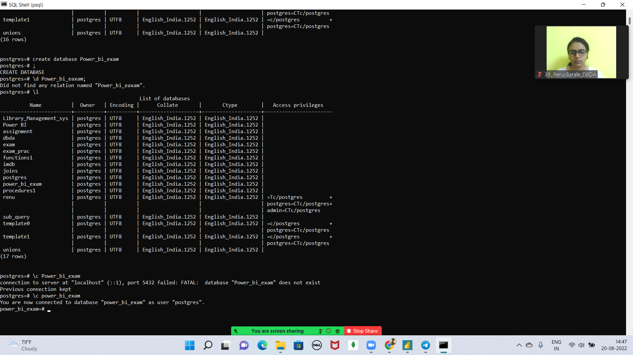

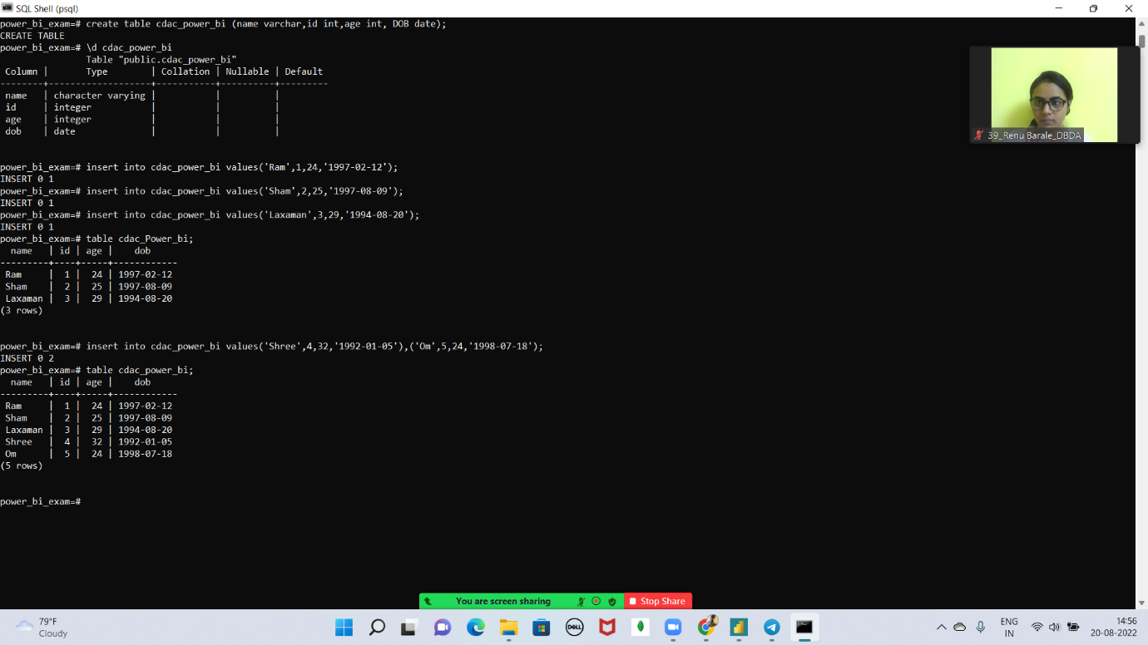

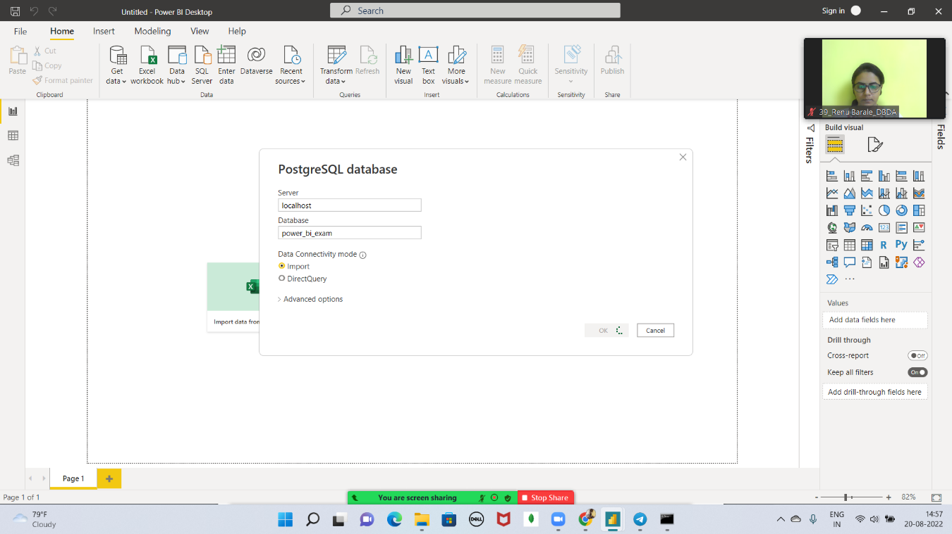

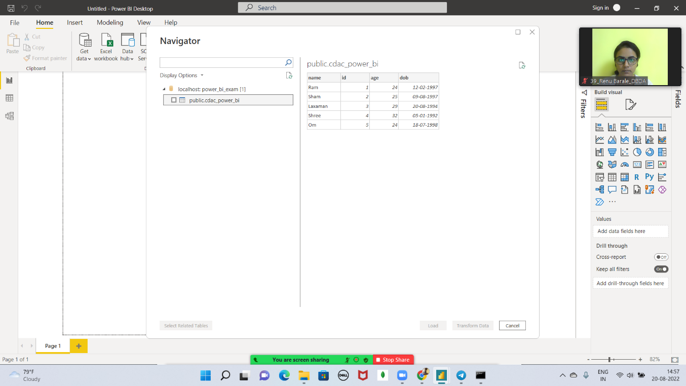

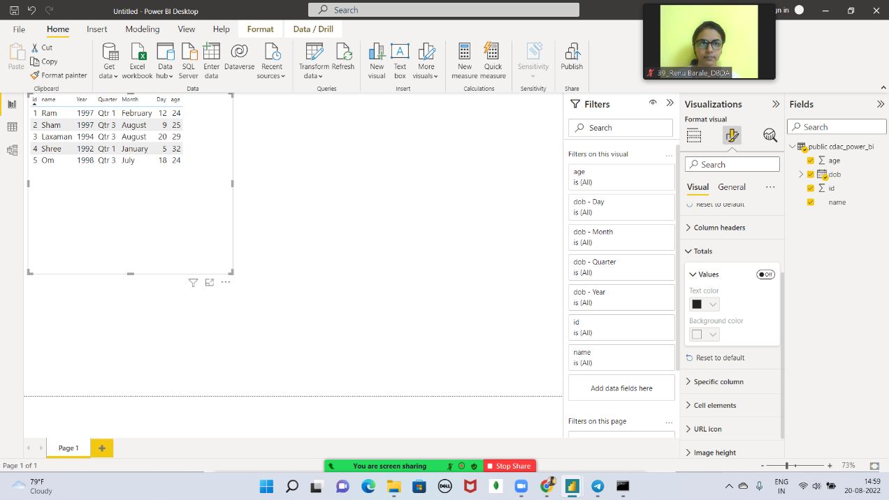

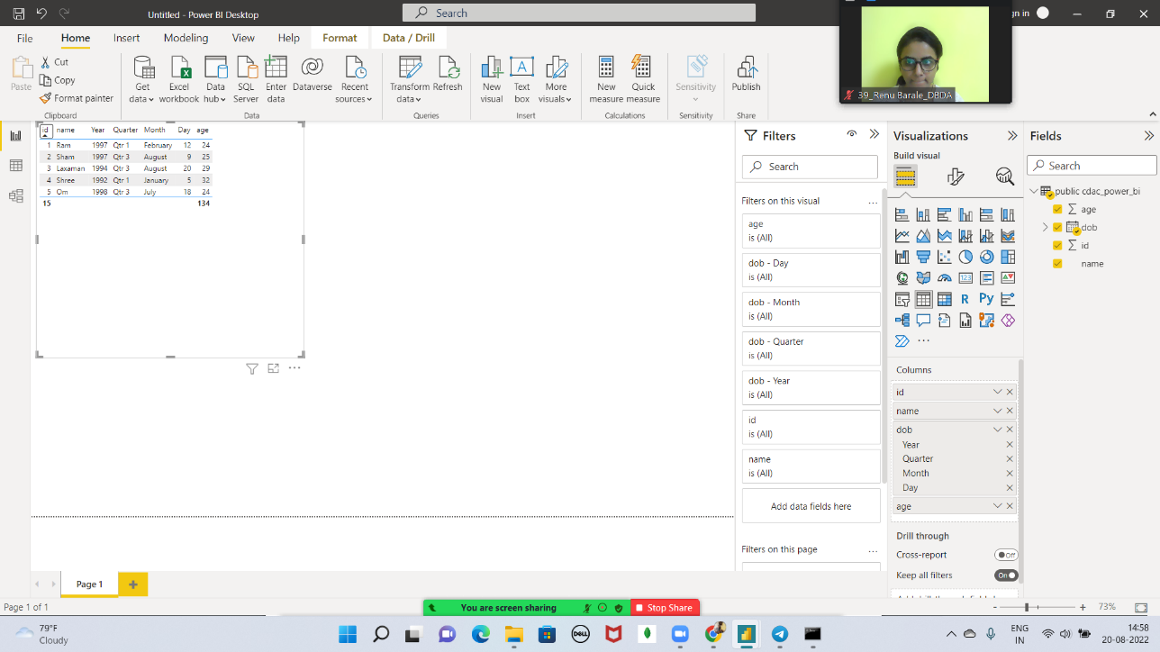

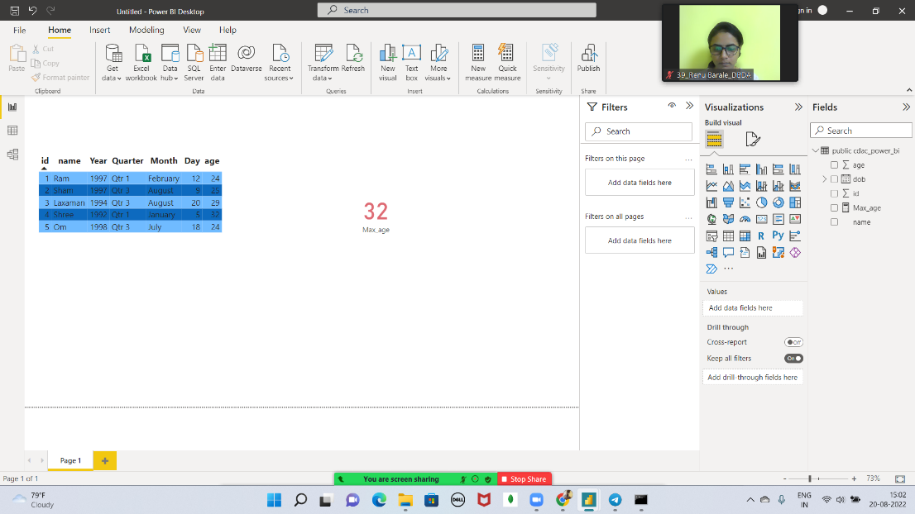

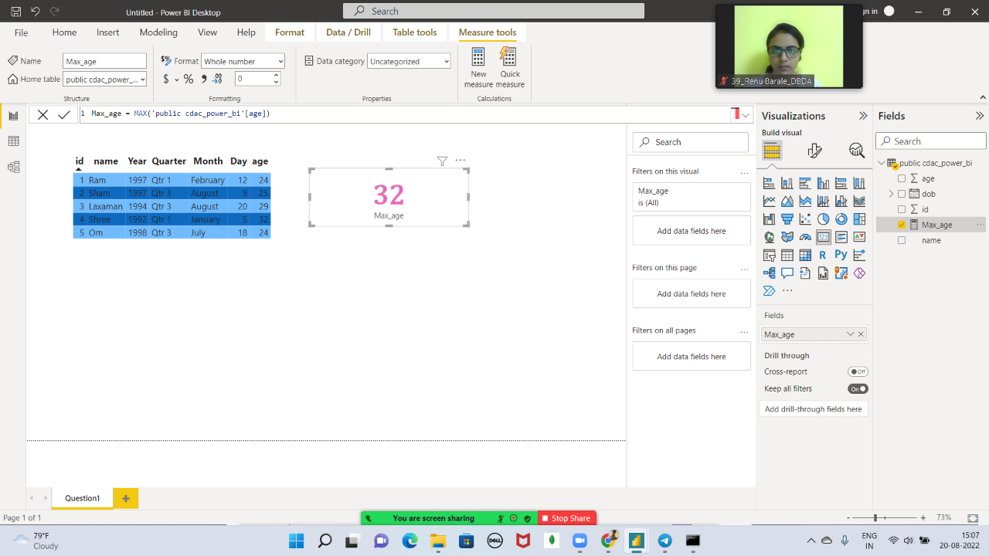

Question 2) On product_table data set do the following (25 Marks)

● Create table chart with title , vendor,customer name,quantity,price,city

● Add new calculated column naming total_sales which is derived from quantity * price

● Add new measure naming max_price to get max of price column and then display every

vendor max price in table chart

● Create pie chart showing the value and percentage of quantity by vendors

● Create one more column naming total_sales_2022 which is derived from quantity *

price * 1.16

● Create clustered column chart showing both total_sales and total_sales_2022

● Create a slicer chart of price

● Calculate avg sales and show in tile ● Create gauge chart with

○ value as total_sales And Maximum value as max of total_sales_2022○ Target Value as average of total_sales

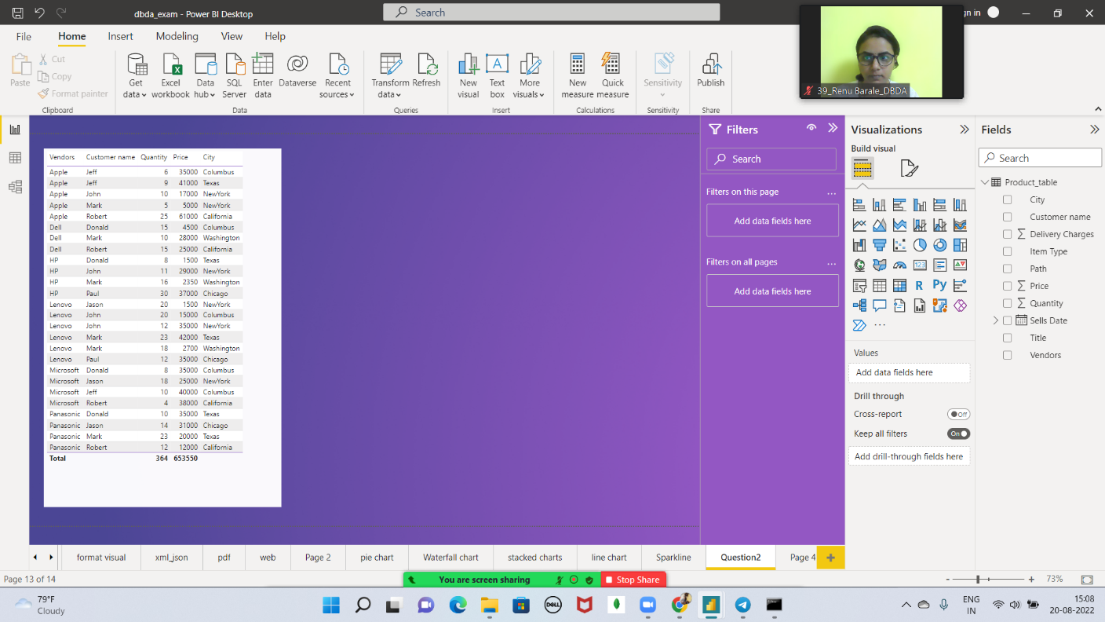

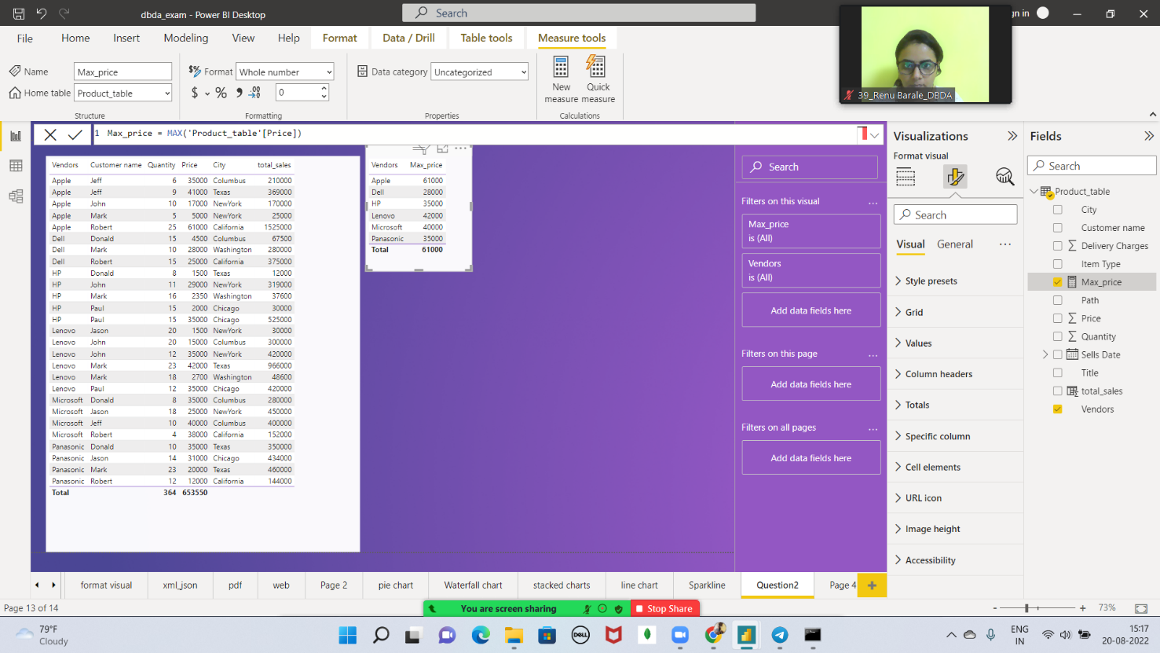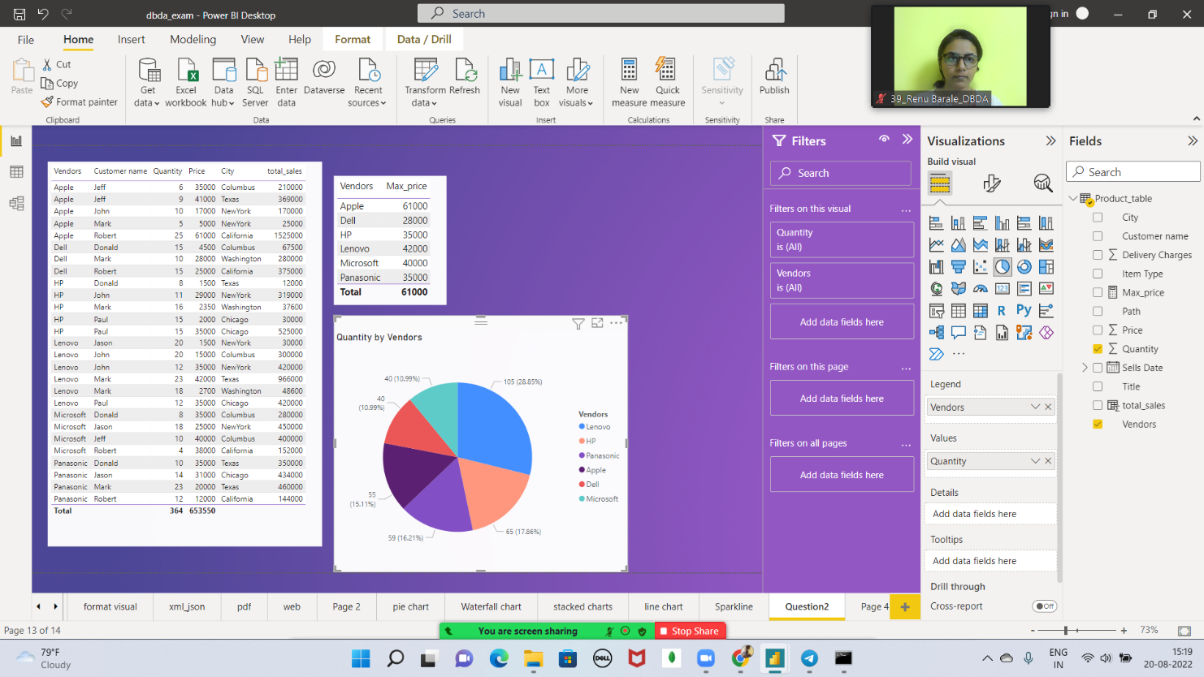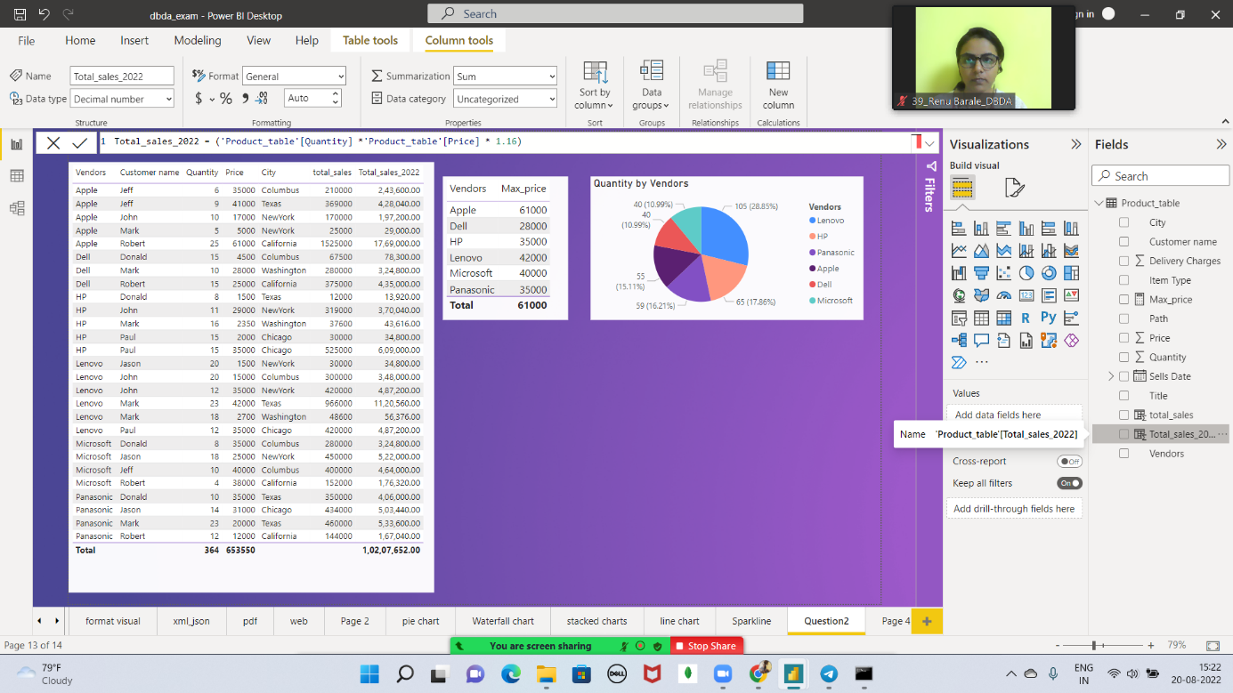

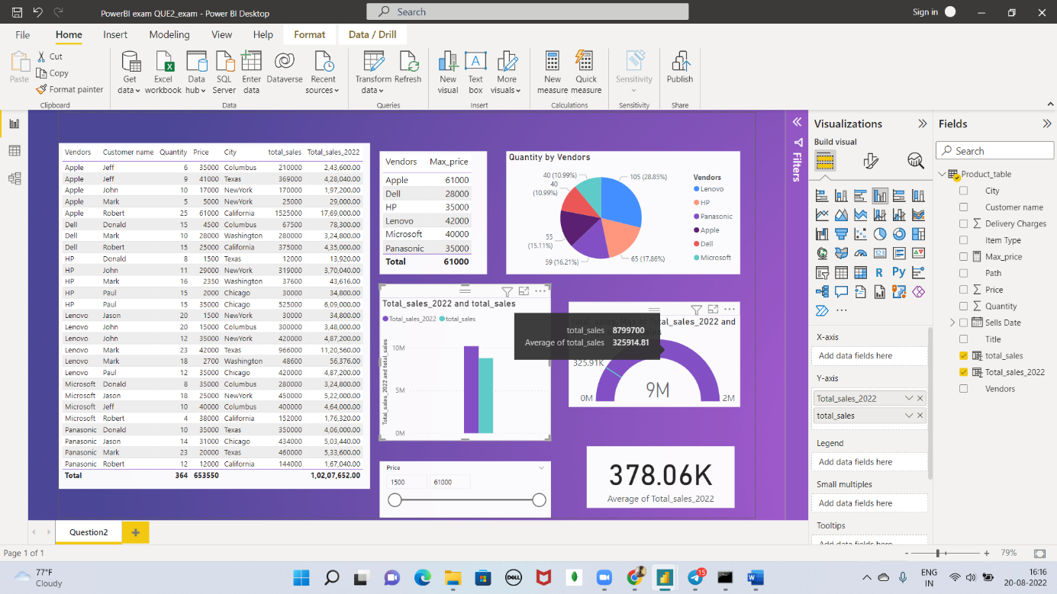

Clustered Column properties

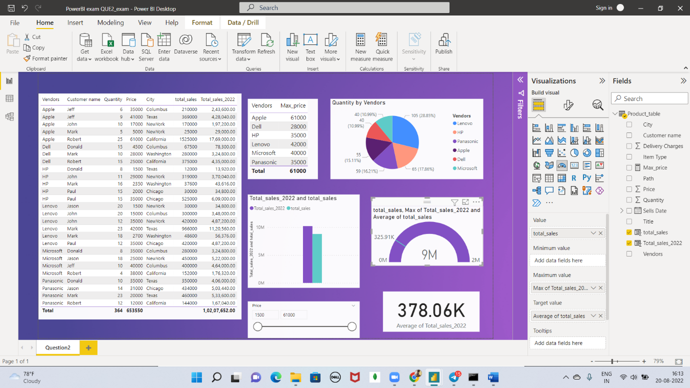

Gauge chart

Scaling price chart

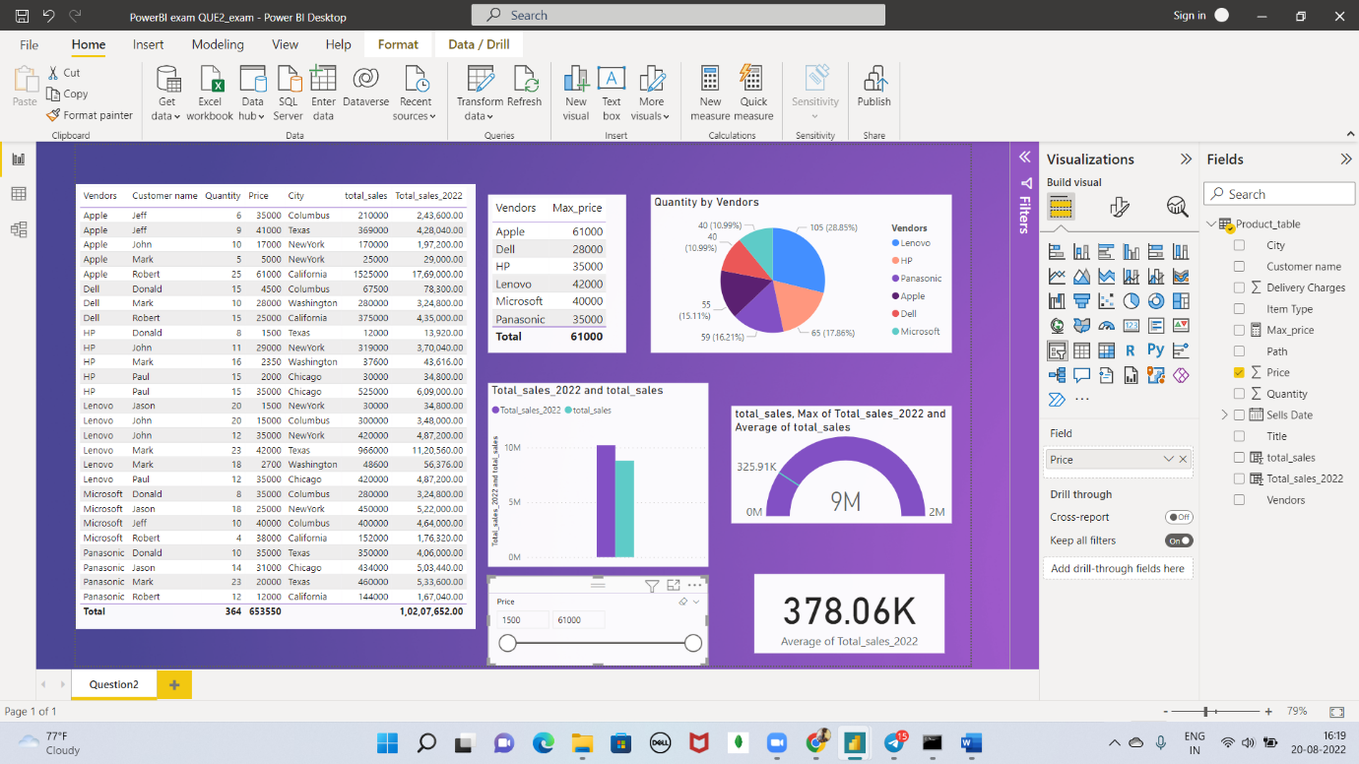

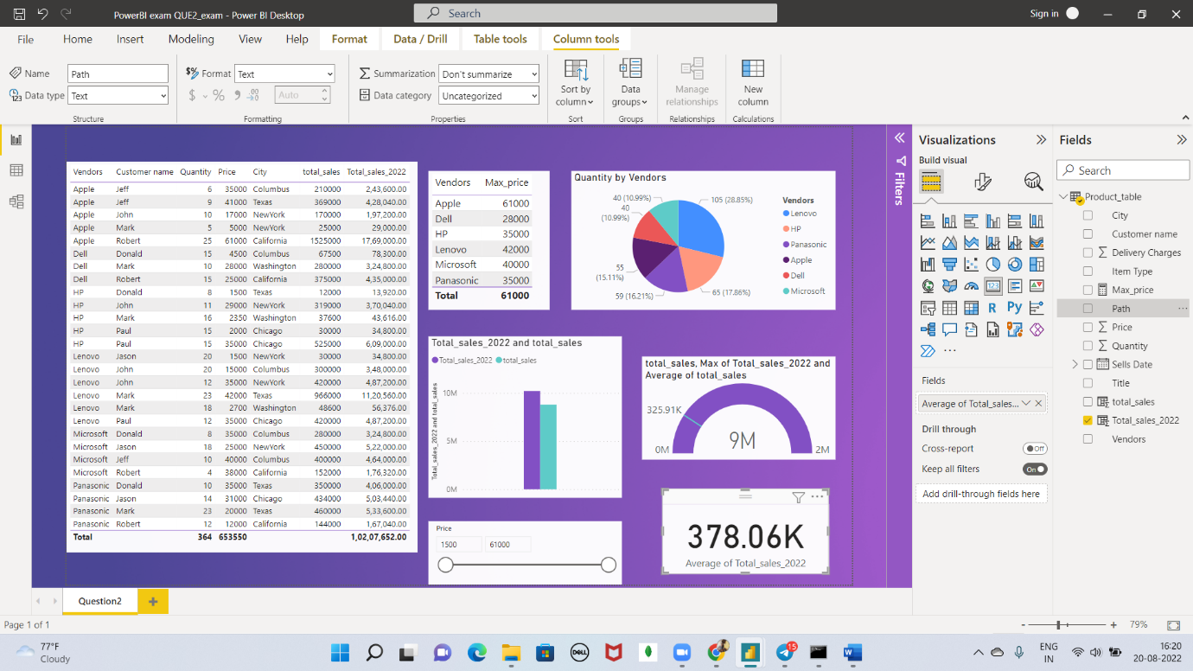

Avg Price CARD

